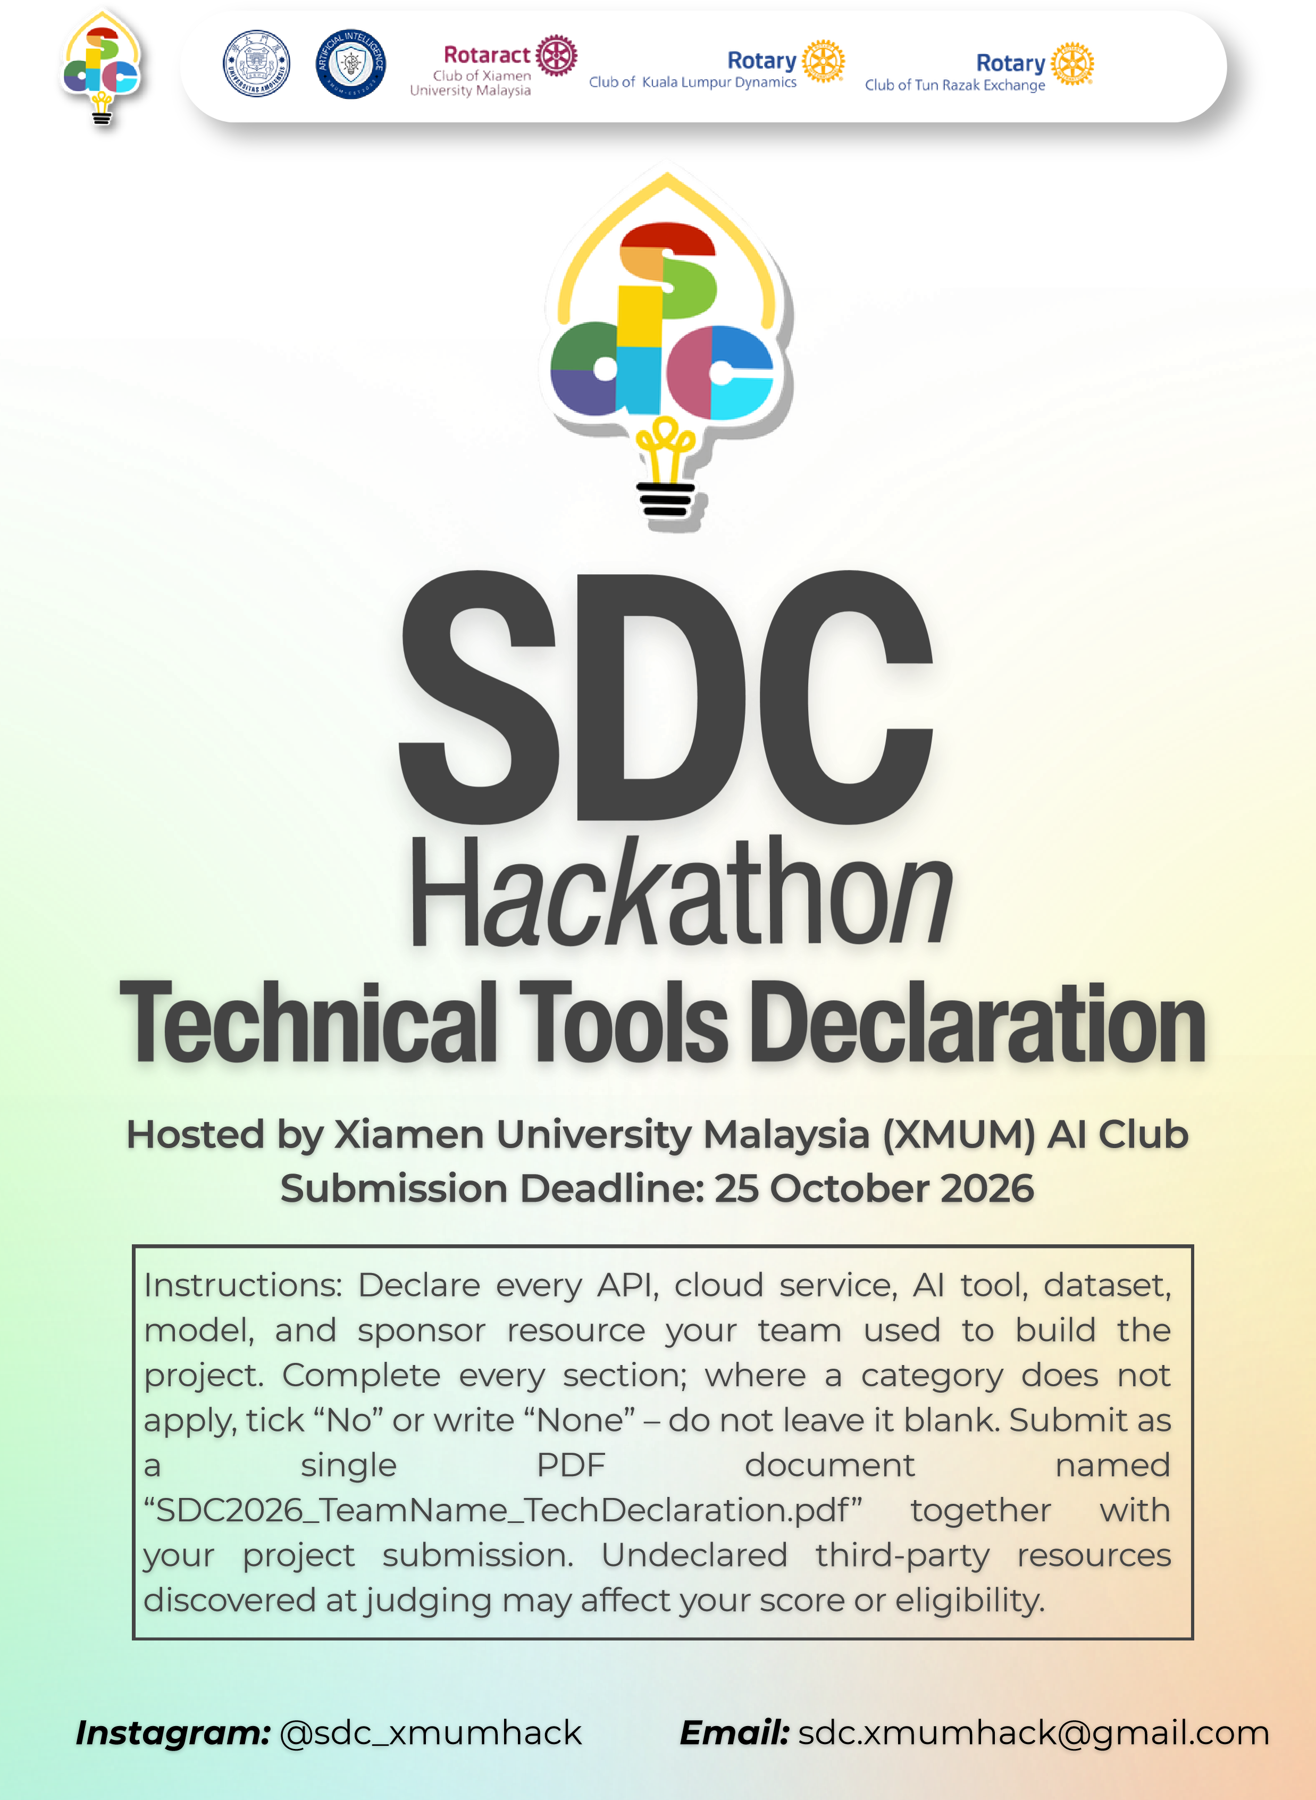
SDC HACKATHON 2026
Technical & Tools Declaration
Hosted by Xiamen University Malaysia (XMUM) AI Club
Submission Deadline: [Insert date]
Instructions: Declare every API, cloud service, AI tool, dataset, model, and sponsor resource your team used to build the project. Complete every section; where a category does not apply, tick “No” or write “None” – do not leave it blank. Submit as a single PDF document named “SDC2026_TeamName_TechDeclaration.pdf” together with your project submission. Undeclared third-party resources discovered at judging may affect your score or eligibility.

1. Team & Project Overview
Team Name | AiX Global
Project / Solution Name | Clarity
Name (Leader) | Bhone Myat Paing Soe
Email & Phone (Leader) | jeremywin37@gmail.com ; 0173481780
University Affiliation(s) | Sunway University, Monash University, University of Nottingham Malaysia
Live Prototype URL | https://ai-x-global.replit.app/  Password: AixGlobal123456789
Code Repository URL (public / access granted to judges) | https://github.com/Mint3Ds/AiX-global

2. Architecture & Technology Stack

2.1 System Architecture Overview
Describe how the components declared in this document connect end-to-end (e.g., user interface → backend → AI model/API → database → cloud hosting). Attach a system block diagram as an appendix if available.
[Maximum 200 words]
The Clarity system utilizes a strictly business-scoped, multi-tier architecture to transform raw customer feedback into verifiable operational workflows. At the presentation layer, the user interface provides a partitioned workspace where synthetic identities manage AI-suggested themes, assign tasks, and review drafted public responses. This frontend communicates directly with a centralized backend API that enforces strict data isolation using a required business ID for all state queries and actions.
Once ingested, the backend orchestrates text processing through external AI APIs. The Jev model initially screens reviews for actionable feedback, utilizing OpenAI as a fallback. OpenAI then extracts exact-quote observations, maps them to dynamic operational themes, and later drafts contextual public replies based on resolved tasks. All end-to-end data provenance is securely persisted in a relational SQL database, immutably linking original review evidence, AI-extracted observations, and subsequent operational activity.
Finally, the system connects to external environments through specialized workflow adapters. Rather than immediately integrating with live cloud platforms, the current architecture locally simulates cloud event buses and external third-party APIs. This allows task handoffs and reply publications to be safely queued and verified without altering live systems. (Please refer to the appended System Block Diagram for visual details).

2.2 Languages, Frameworks & Libraries
List the main programming languages, frameworks, and third-party libraries that your team did not create. Open-source use is permitted provided it is declared and properly licensed/attributed.

3. APIs & Cloud Services

3.1 External APIs
List every external API your solution calls (GenAI, maps, payments, messaging, data feeds, etc.). Do not include API keys or secrets in this document.
API & Provider | Purpose in Project | Access Tier (free / paid / sponsor-provided)
JEV | Classification of reviews into helpful / useless ; positive / negative ; etc. | API (paid)
OpenAI | Backup for classification ; basic analysis of review | API (paid)

3.2 Cloud Platforms & Deployment
List every cloud service used for hosting, storage, databases, authentication, or compute, and indicate how the prototype is deployed.
Service & Provider | Purpose in Project | Plan / Region
Replit | Live demonstration of prototype | Core (sponsor-provided)

4. AI Tools, Models & Datasets

4.1 AI Models Used in the Solution
List every AI model embedded in or called by your application, including pre-trained, fine-tuned, and self-trained models.
Model & Version | Source / Provider | Usage (pre-trained / fine-tuned / self-trained) | License / Terms
Jev 1.14.0 (latest) | Typesafe AI | Pre-trained | Proprietary Commercial Agreement
GPT 5 Mini | OpenAI | Pre-trained | Proprietary Commercial Agreement

4.2 Datasets
List all datasets used for training, fine-tuning, evaluation, or in the running application. State clearly if a dataset contains personal or sensitive data.
Dataset Name | Source / URL | Type (public / private / self-collected / synthetic) | License | Personal Data? (Y/N)
Harbour House Central | Self | Synthetic | N/a | N
Nusa Table Sunway | Self | Synthetic | N/a | N
Luma Salon | Self | Synthetic | N/a | N

4.3 AI-Assisted Development Tools
Tools used to help write code, design, content, or documentation (e.g., chat assistants, code completion tools, image generators). Declaring these tools does not reduce your score; undeclared use may.
Did your team use any generative-AI tool to help create code, design, text, or other project material?
☑ Yes ☐ No
If yes, list them below:
Tool & Version | Used For | Extent of Use (minor / moderate / major)
Codex with GPT-6.1 Sol | Skeleton of project, research, coding, front-end, graphic design | Major
Antigravity with Gemini 3.1 Pro and Gemini 4 Argon | Research, coding, front-end design, writing (ex.readme), proofreading, verification of requirements | Moderate

Briefly describe how your team reviewed, tested, and took responsibility for AI-generated output:
[Maximum 100 words]
Our team treated AI-generated code and content as helpful starting points rather than final solutions. We validated AI outputs by integrating them into our codebase and running functional tests to ensure everything worked as intended. We reviewed the generated logic during our standard debugging and integration process to confirm it aligned with our project requirements. Any documentation or design suggestions were manually reviewed and adjusted for accuracy. Ultimately, our team takes full ownership of the final product, ensuring all AI contributions were actively tested and verified within our system.

5. Sponsor-Provided Resources
Declare any official SDC sponsor-provided GenAI API, cloud credits, tools, mentoring, or data that your team used.
Did your project use any official SDC sponsor-provided resource?
☑ Yes ☐ No
If yes, list them below:
Sponsor | Resource (API / credits / platform / data) | How It Was Used in the Project
Replit | Credits | Cloud deployment of live prototype and database management

Was the sponsor resource essential to the core functionality of the prototype, or could it be replaced? Explain briefly:
[Maximum 100 words]
While our Next.js and Drizzle ORM architecture is highly portable and could technically be migrated to alternative cloud providers, Replit was essential for delivering a fully functional prototype within the hackathon’s strict timeframe. It provided the managed PostgreSQL database required for our multi-tenant data architecture and the secure environment secrets necessary to keep our external API keys strictly server-side. Without this sponsor resource, configuring a reliable, cloud-ready database and hosting environment would have significantly delayed our core application development.

6. Security, Privacy & Responsible Use

6.1 Data Handling & Privacy
What user or personal data does your application collect, store, or send to third-party services (including AI APIs)? How is it protected, and how long is it kept? State “No user data is collected” if applicable.
[Maximum 150 words]
No user data is collected.

Currently, the Clarity prototype operates exclusively on synthetic fixture data. No actual personal information is collected, stored, or transmitted to third-party AI services.

However, as we advance to integrate live feedback streams like Google Reviews, our production architecture will strictly comply with Malaysia's Personal Data Protection Act 2010 (PDPA, Act 709). The system will implement automated anonymization protocols to explicitly mask all Personally Identifiable Information (PII) before transmitting any live review payloads to external GenAI APIs (Jev and OpenAI) for screening and observation extraction. This ensures that while the AI analyzes the business context of a customer complaint, sensitive user identities remain securely isolated and protected within our Replit-managed database.

6.2 Known Limitations & Risks
Identify the main technical limitations of your AI components (e.g., hallucination, bias, rate limits, dependency on a single provider) and any mitigation you have implemented.
[Maximum 150 words]
Clarity’s AI components face risks including API rate limits, provider downtime, and potential model hallucinations. To mitigate dependency on a single provider, our architecture implements a reliable fallback mechanism: if the primary Jev classification model fails or is uncertain, the system automatically routes the request to an OpenAI model.
To address the critical risk of AI hallucination, where models might invent complaints, Clarity enforces exact-substring extraction. The AI must preserve the customer’s original words as evidence rather than paraphrasing. Furthermore, we mitigate automated errors through strict human-in-the-loop safeguards. The system cannot resolve operational tasks automatically; it requires an explicit owner verification note. Additionally, if the AI detects unresolved complaints within a mixed review, it attaches a partial-reply warning to the draft. This warning intentionally restricts batch approval, ensuring mandatory human oversight before any external customer communication is finalized.

7. Compliance & Readiness Checklist
Tick all boxes that apply before submitting.
☑ | All APIs, cloud services, AI tools, models, and datasets used in the project are declared in this document.
☑ | All third-party code, datasets, and models are used in accordance with their licenses, and attribution is provided where required.
☑ | No API keys, passwords, or other credentials are exposed in the code repository, prototype, or this document.
☑ | Any use of generative-AI tools for development has been disclosed and reviewed by the team.
☑ | Any use of official SDC sponsor resources has been declared in Section 5.
☑ | The prototype described here is accessible to judges through the links provided in Section 1.
☑ | All fields in this template have been completed within the word limits stated.

8. Declaration
By submitting this document, the team leader confirms that the information provided is complete and accurate to the best of the team’s knowledge, and that every API, cloud service, AI tool, dataset, model, and sponsor resource used in the project has been declared.
[Signature]

[Date] 10/25/2026

